1
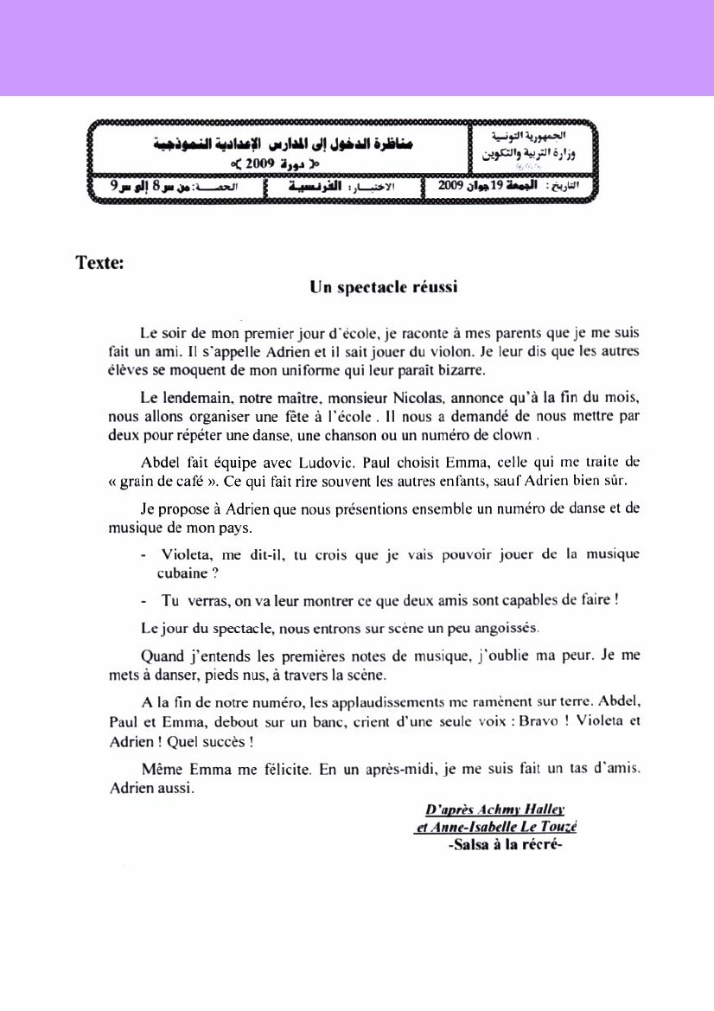
2
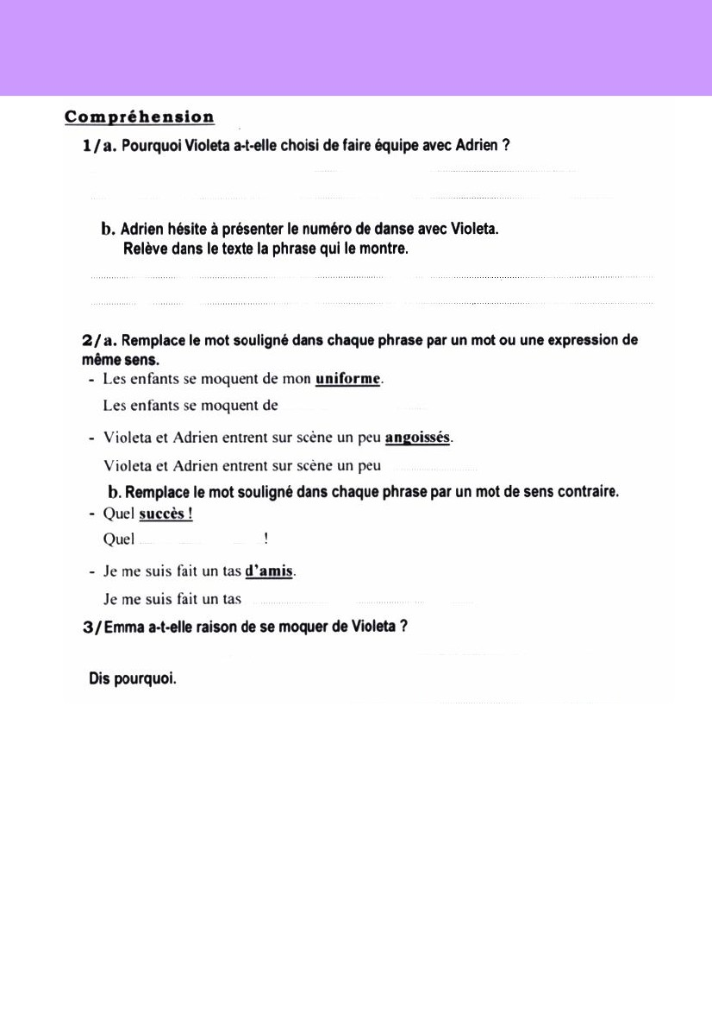
3
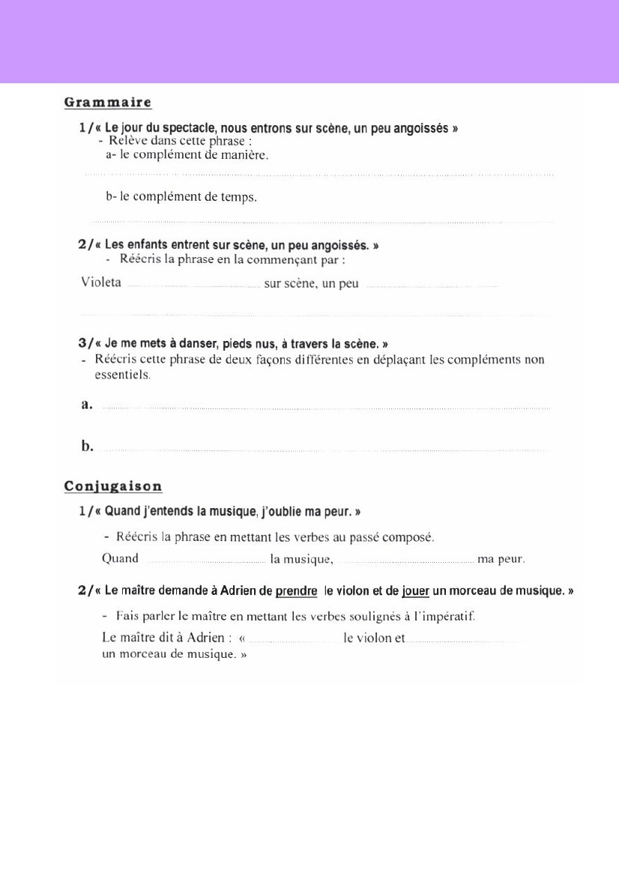
……………………………………………………………………………………………………...
……………………………………………………………………………………………………...
……………………………………………………………………………………………………...
……………………………………………………………………………………………………...
……………………………………………………………………………………………………...
……………………………………………………………………………………………………...
……………………………………………………………………………………………………...
……………………………………………………………………………………………………...
……………………………………………………………………………………………………...
4
